IOT BASED AIR QUALITY MONITORING

PROJECT REPORT

SUBMITTED BY

MENTOR STUDENT MEMBERS

MS.R.PREETHI(AP\ECE) R.GNANAMOORTHI

A.GOPINATH

C.GURUNATHAN

E.KESAVAKALISHWARAN

R.SURYA

ABSTRACT

"In recent years, deteriorating air quality has become a pressing concern, leading to adverse effects on public health and the environment. This study introduces an innovative approach to address this issue by leveraging the Internet of Things (IoT) technology. The proposed system involves the deployment of sensor nodes equipped with various environmental sensors to continuously monitor air quality parameters such as particulate matter (PM2.5 and PM10), carbon dioxide (CO2), ozone (O3), and nitrogen dioxide (NO2). These sensor nodes are interconnected through IoT-enabled devices and transmit real-time data to a central server for analysis. Utilizing advanced data analytics techniques, the collected information is processed to assess air quality levels and identify potential sources of pollution. Additionally, the system incorporates a user-friendly interface, allowing citizens to access real-time air quality data via web or mobile applications. This initiative not only provides valuable insights into air pollution patterns but also empowers communities and authorities to make informed decisions aimed at improving air quality and fostering a healthier environment for all."

INTRODUCTION:

Air quality monitoring using IoT (Internet of Things) refers to the application of smart, connected devices and sensors to assess and manage the quality of the air we breathe. With the rapid advancement of technology, IoT has emerged as a powerful tool in the field of environmental monitoring. By deploying sensors in various locations, IoT enables real-time collection of data related to air pollutants, such as particulate matter (PM2.5 and PM10), volatile organic compounds (VOCs), carbon monoxide (CO), nitrogen dioxide (NO2), and ozone (O3).

This innovative approach to air quality monitoring offers several advantages, including increased accuracy, timely data analysis, and cost-effectiveness. IoT devices can collect vast amounts of data, allowing researchers and policymakers to make informed decisions to mitigate the adverse effects of air pollution on public health and the environment. By leveraging IoT technology, air quality monitoring systems can provide valuable insights, facilitate early warnings, and empower communities to take proactive measures to improve air quality and create a healthier living environment for everyone.

PROPOSED SYSTEM:

An embedded system model for air quality monitoring: -

Published in: Computing for Sustainable Global Development (INDIA.Com), 2016 3rd International Conference

Authors: Sneha Jangid, Sandeep Sharma (School of ICT, Gautam Buddha University, Greater Noida, India)

The objective of the paper is to present a system model which can facilitate the assessment of health impacts caused due to indoor air pollutant as well as outdoor and can intimate the human prior about the risk he/she going to have, here we are focusing our work in context to allergic patients as they will be informed by this tool such that they can secure themselves without actually experiencing the risk factors, here a sensing network-based microcontroller equipped with gas sensors, optical dust particle sensor, humidity, and temperature sensor has been used for air quality monitoring. The design included various units mainly: sensing unit, processing unit, power unit, display unit, communication unit. This work will apply the techniques of electrical engineering with the knowledge of environmental engineering by using sensor networks to measure Air Quality Parameters.

Now in this project, we are using the locally available gas sensors for observing polluted gases like Carbon monoxide (CO), Carbon dioxide (CO2), and parameters like temperature, humidity. By using this method people can view the level of pollution through a wireless system. It reduced cost, is reliable, and is comfortable for any place where we are monitoring the gases.

COMPONENTS:

* MQ-135 GAS SENSOR
* MQ-7 GAS SENSOR
* LCD SCREEN DISPLAY
* SYSTEM TO MONITORING THE AIR QUALITY
* ESP8266 WI-FI MODULE (OR) AURDINO UNO

PROGRAM:

#include <LiquidCrystal_I2C.h>

LiquidCrystal_I2C lcd(0x20, 16, 2); // adjust the I2C address and display size as needed

void setup() {

lcd.init();

lcd.backlight();

lcd.print("Air Quality");

lcd.setCursor(0, 1);

lcd.print("Monitoring Sys");

delay(2000);

lcd.clear();

}

void loop() {

float co2sensorValue = analogRead(A0);

float co2voltage = co2sensorValue * (5.0 / 1023.0);

float co2resistance = (5.0 - co2voltage) / co2voltage;

float co2ppm = (1.0 / co2resistance) * 10000;

float o2sensorValue = analogRead(A1);

float o2voltage = o2sensorValue * (5.0 / 1023.0);

float o2resistance = (5.0 - o2voltage) / o2voltage;

float o2ppm = (o2resistance - 76.63) / -0.127;

float o2percentage = o2ppm / 10;

lcd.clear();

lcd.setCursor(0, 0);

lcd.print("CO2:");

lcd.print(co2ppm);

lcd.print("ppm");

lcd.setCursor(0, 1);

lcd.print("O2:");

lcd.print(o2ppm);

lcd.print("ppm");

lcd.clear();

lcd.setCursor(0, 0);

lcd.print(" (");

lcd.print(o2percentage);

lcd.print("%)");

//Display the quality of the air

if (co2ppm > 1000 || o2percentage < 19.5) {

lcd.clear();

lcd.print("Impure air");

lcd.setCursor(0, 1);

lcd.print("Evacuate room");

} else if (co2ppm > 700 || o2percentage < 21) {

lcd.clear();

lcd.print("Normal air");

} else {

lcd.clear();

lcd.print("Clean air");

}

delay(1000);

}

BLOCK DIAGRAM:

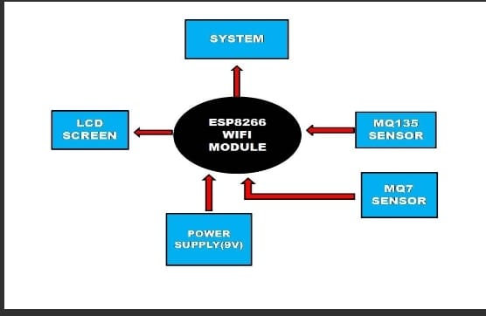

PROTOTYPE:



CIRCUIT DIAGRAM:

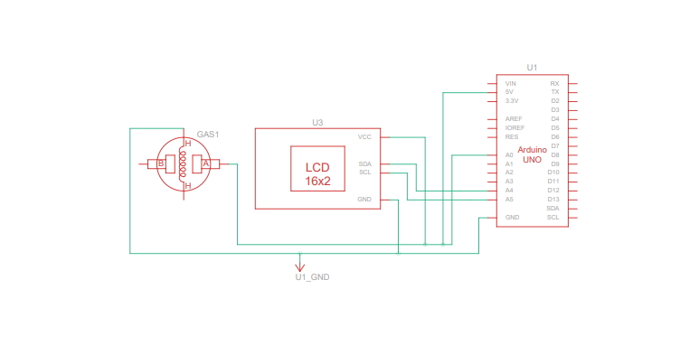

WORKING:

STEP1:TURN ON THE AURDINO.

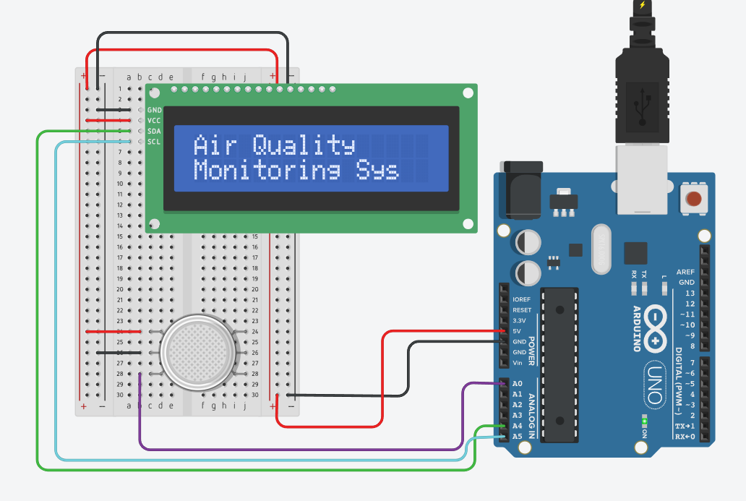

STEP2:ANALYZE THE AIR QUALITY USING SENSOR.

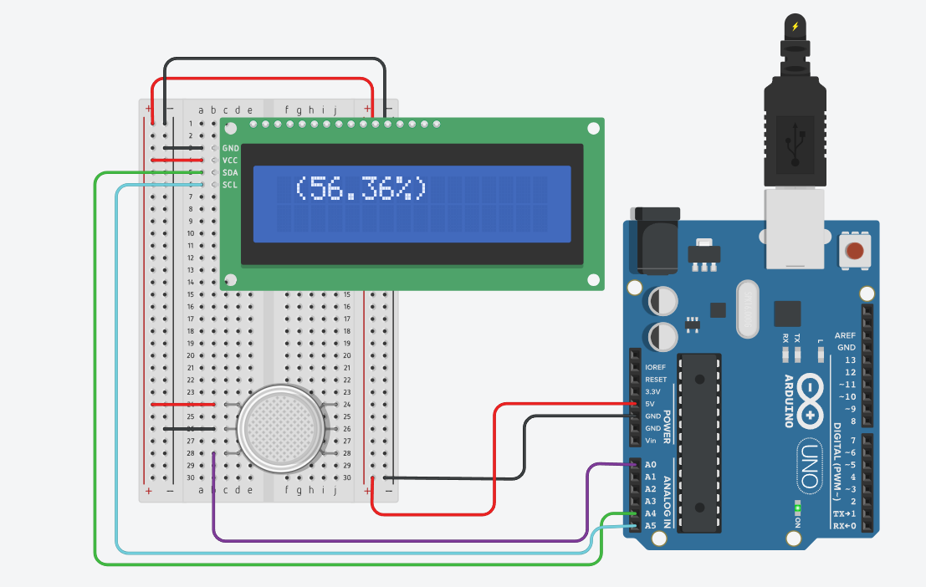

STEP3:PRODUCE THE OUTPUT IN LCD DISPLAY.

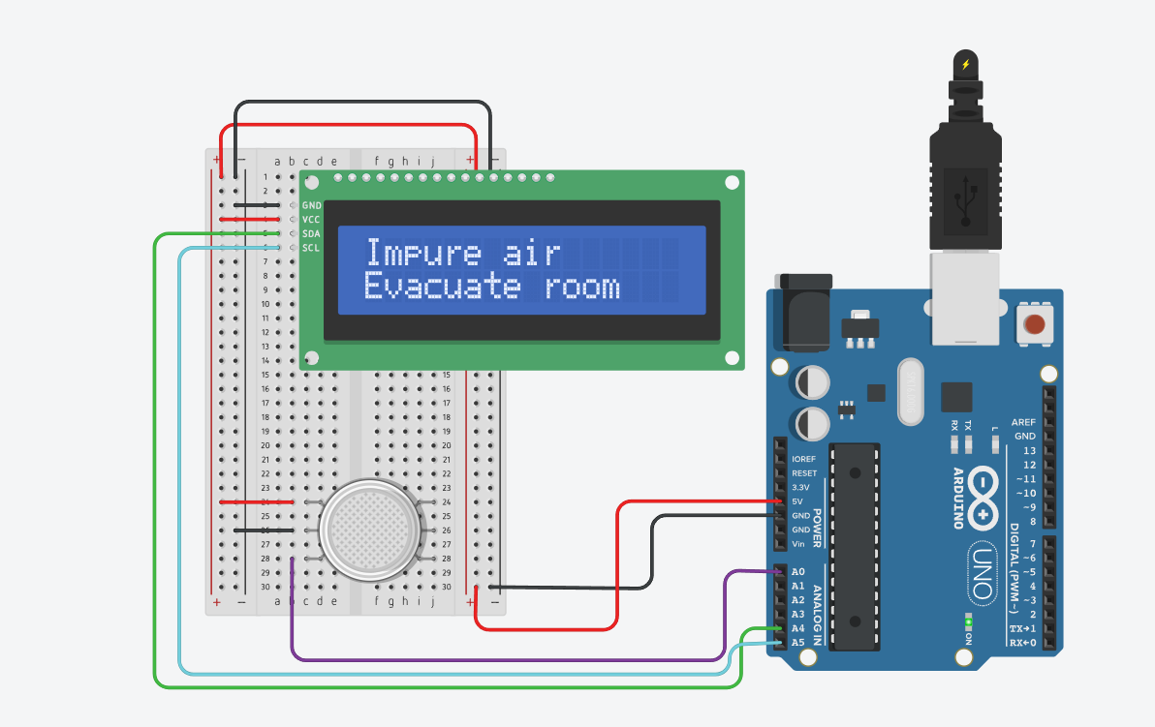

CONCLUSION:

In conclusion, air quality monitoring plays a crucial role in safeguarding public health and the environment. By continuously assessing and analyzing air pollutants, we can make informed decisions to mitigate their impacts, improve air quality, and create a healthier and more sustainable future. Effective monitoring, data analysis, and regulatory actions are essential components in the ongoing effort to ensure clean and safe air for all.